**­**

**ALL INDIA SENIOR SCHOOL CERTIFICATE EXAMINATION**

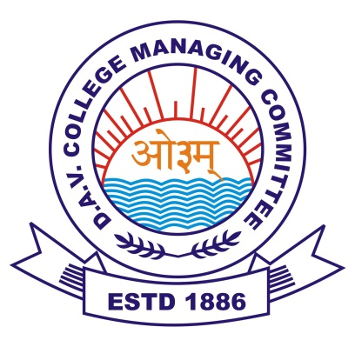

**DAV Public SCHOOL**

**ECL PANDAVESWAR**

PHYSICS ACTIVITY COPY

**NAME : -- ARNAB CHATTERJEE**

**CLASS :-- XII**

**ROLL :--**

**SUBJECT :-- PHYSICS**

**SESSION :-- 2021-2022**

**ALL INDIA SENIOR SCHOOL CERTIFICATE EXAMINATION**



**DAV Public SCHOOL**

**ECL PANDAVESWAR**

PHYSICS PRACTICAL COPY

**NAME : -- ARNAB CHATTERJEE**

**CLASS :-- XII**

**ROLL :--**

**SUBJECT :-- PHYSICS**

**SESSION :-- 2021-2022**